THE GROBY SURGERY
FORM OF AUTHORITY

PATIENT’S NAME: _____________________________________
ADDRESS: _______________________________________________
______________________________________
DATE OF BIRTH: ________________________

I fully consent to the person(s) named below discussing my care and medical information on my behalf, including results and prescriptions.
NAME OF NOMINEE | RELATIONSHIP TO PATIENT | CONTACT NUMBER(S)
1.
2.
3.
4.

PATIENT SIGNATURE: ______________________
NOMINEE/S SIGNATURE: 1. _________ , 2. _________, 3. _________ , 4. _________
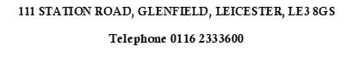
DATE: _____________________________

